(Approx. 1977 words)

COMPLETE ROBOCALL DETERRENCE
A two-step approach: prevent the ring and convince the robocaller that your line is disconnected.
Part 3 of a 3-part article series
By John Krout, Presenter & Newsletter Contributor
Potomac Area Technology and Computer Society
https://www.patacs.org
jkrout.apcug.presenter (at) gmail.com

INTRODUCTION

In Part 1 of this series, you learned how to configure your smartphone so that only your Contacts will ring your phone, a Whitelist strategy.

In Part 2, you learned robocall systems respond to the Special Information Tones (SIT) that begin certain phone network messages, such as the number has been disconnected, by removing the dialed number from the robocall systems internals list of known valid numbers. In addition, you learned how to obtain a recording of SIT, how to record your voice, and how to combine SIT and your voice recording into a complete voicemail greeting using Audacity.

In this conclusion, you will learn how to record that complete greeting as your custom voicemail greeting, using your computer to play the combined greeting while your phone "listens." The key to this puzzle is that the smartphone and the recording system for voicemail greetings expect greeting sounds to come in through the smartphone's microphone.

There are at least three ways to feed audio from your computer into the smartphone microphone.

THE SIMPLE APPROACH

The low-tech, low fidelity way is to use your computer to "speak" into the phone.

The steps are simple: prepare to play the combined greeting on your computer speakers. Then, on your phone, work through the steps to begin recording your customized voicemail greeting. Hold the phone up to the computer speaker, tap the final Record button on the phone, and immediately start the audio playback on the computer. When the combined greeting playback is done, tap the Stop Recording button on the phone.

There are problems with this simple approach. First, this approach also records environmental sounds such as air conditioning or heating, other people, or passing vehicles. Second, the quality of the recording is limited by the quality of the speakers. The weakest link in any audio system is the speakers. Third, we need to make sure the high frequencies of the SIT are faithfully recorded so that robocaller systems, when they reach voicemail, will have no doubt that robocallers have heard and recognized SIT at the start of your greeting.

THE WI-FI APPROACH

It is possible to connect and transfer audio from my computer to the microphone device of my Android phone. Using this approach, the phone can record the incoming audio from the computer, just as if the audio was being delivered through the microphone. However, since speakers are not involved, the audio received is high quality. Simple improvements can further increase audio quality.
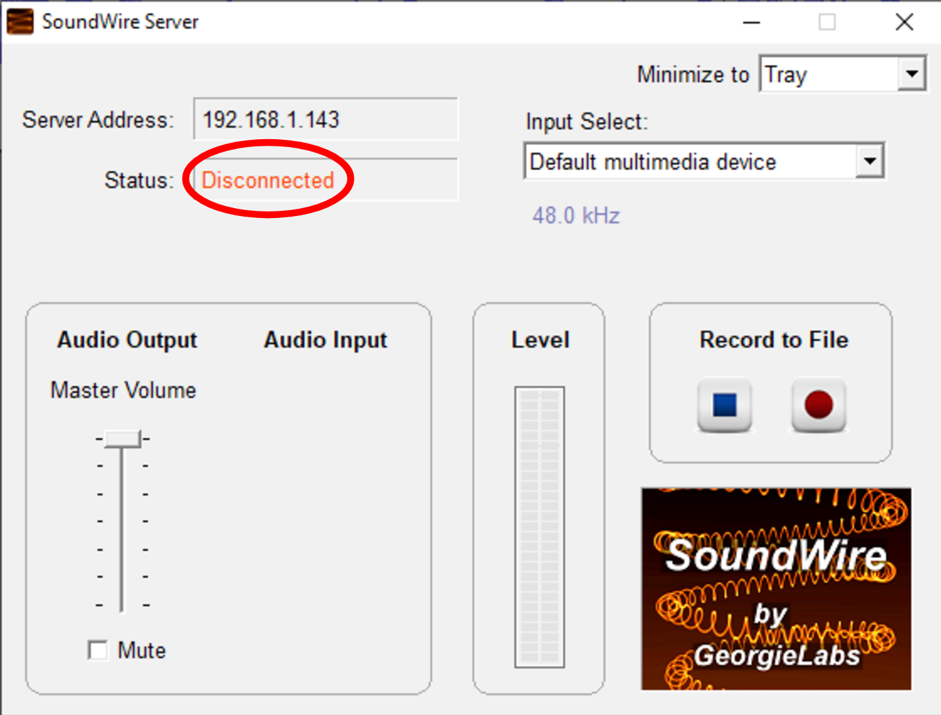Illustration 1
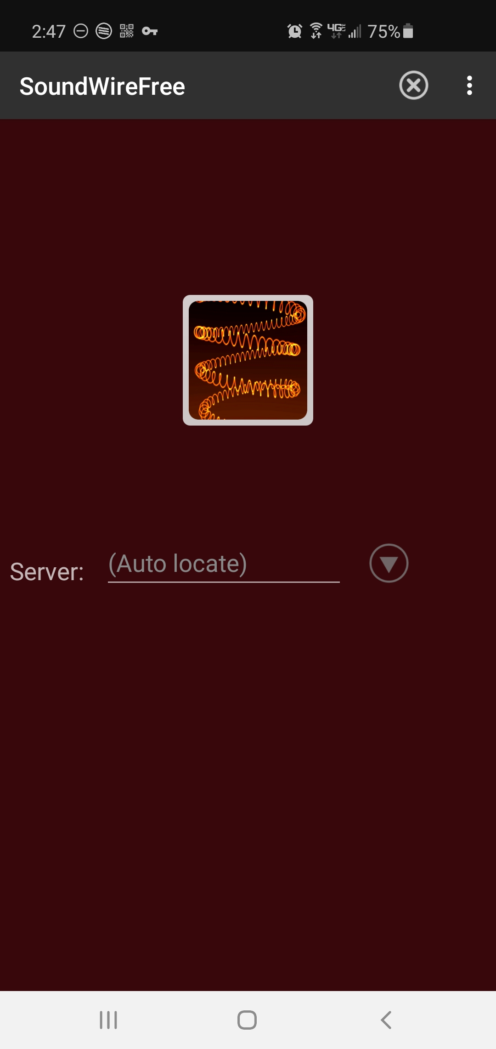Illustration 2
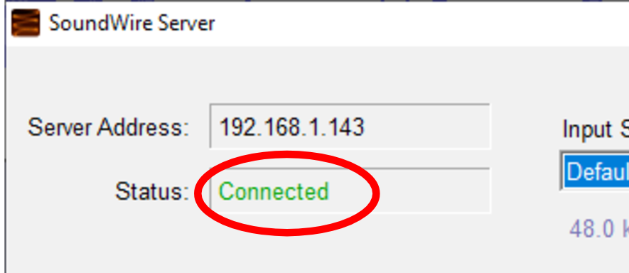Illustration 3

To make this happen, I found and tested an Android app called SoundWire, and its corresponding personal computer application called SoundWire server. Both are freely available. There are versions of SoundWire Server available for Windows, Linux, and Raspberry Pi. The app is available on the Google Play Store, and SoundWire Server can be obtained from this URL: http://georgielabs.net.

The basic idea is that the SoundWire Server captures audio being played on your computer and sends captured audio via your Local Area Network Wi-Fi to the SoundWire app on your phone. The SoundWire app on your phone then injects the incoming audio into your smartphone's microphone device and plays it on your phone's internal speakers.

To accomplish the SoundWire connection of the app and the server, you must not run a Virtual Private Network (VPN) client on your computer or phone. Using a VPN client means the two cannot be connected via your WiFi.

STEP 1. Start the SoundWire Server application on your computer. Initially, SoundWire Server will display a window like that shown in Illustration 1. Note the status Disconnected, which appears in red and is circled. That status is normal at startup.

STEP 2. On your computer, start the audio playback application, which will play your combined audio greeting. Then, load the combined audio greeting in that application.

STEP 3. On your Android smartphone, start the SoundWire app. It will look like the app shown in Illustration 2. Note the big wire-filled button which dominates the app screen.

STEP 4. This step connects the SoundWire app and the SoundWire server application across your Wi-Fi.

On your smartphone, tap and hold the wire-filled button in the SoundWire app for about 1/3rd second. The SoundWire Server application status should change to Connected on the computer, as shown in Illustration 3.

The SoundWire connection method described above is known as the automatic method. If it does not work for you, try the manual method, as follows.

Note the IP address displayed by the SoundWire server, in the field Server Address, directly above the Status field. You can see that IP address in Illustration 1.

Type that IP address into the SoundWire app field named Server. Then re-try the long tap on the big button in the app.

When you connect SoundWire for the first time, I suggest you use a smartphone voice recording app to test audio transfer and recording quality on the phone. There is an excellent variety of free voice recording apps available on the Google Play Store for this testing purpose.

THE TEST

After establishing the SoundWire connection, as shown above, start the voice recording app on your smartphone, tap the Record button in that app, and start your audio playback application on your computer. For example, the phone on my WiFi received audio about 1/4 second after the computer played it.

Here are more steps to improve audio quality when using SoundWire. While using SoundWire, the Android phone physical microphone still works. However, it will pick up audio from your computer speakers, which means the voice recorder app will pick up an echo, and it will pick up ambient environmental noises. I strongly suggest blocking the smartphone microphone with duct tape, electrical tape, or the like to prevent that. Also, while doing the test, I strongly recommend listening to the computer audio on earbuds or headphones instead of speakers.

When the computer audio finishes playing, tap the Stop button of the voice recorder app on your phone. Play back the voice recorder recording to make it recognizable, fairly loud, and free of ambient noises and echoes.

USING THE COMBINED GREETING ON ANDROID

Since each carrier and smartphone have different ways of starting and ending an effort to record the customized voice greeting, I must leave those details for you to figure out.

On Verizon Wireless, my Samsung Galaxy S10 phone, running Android 10 (and later 11), the voicemail greeting recording is found in the Voicemail app Settings. I strongly suggest practicing the recording start steps two or three times to become familiar with the somewhat complex sequence of steps before you attempt the actual recording.

Once you figure it out, the recording process is basically the same as the test process above. However, instead of using the voice recorder app, you use the Voicemail app or whatever other app your carrier and smartphone provide for recording a customized voicemail greeting.

ANALOG AUDIO CONNECTION TO IPHONE

I could not find an iPhone equivalent for SoundWire. So, for iPhones, the approach is to feed analog audio coming from the computer speaker/headphone socket into the headset socket of the iPhone.

Such a technique faces some challenges. First, the audio level coming out from a headphone socket is line level; the audio level expected on the headset socket is mic level, roughly 1/1,000th of the line level voltage. We need a method to reduce that audio signal voltage. Cables that accomplish this signal voltage reduction are called attenuator cables. Second, the iPhone headset socket includes a microphone input connection and two headphone output connections. We need a way to connect the analog audio from the computer specifically to the socket's microphone input connection.

These days, a single cable can resolve both issues. For example, some attenuator cables provide a monophonic 1/8th inch diameter phono socket and a 1/8th inch diameter plug for connection to the iPhone headset socket.

The third challenge was more vexing. Even when the Windows 10 audio volume was fully turned up, my audio feed volume to my phone's headset socket was so low that Verizon Wireless refused to use my custom voicemail greeting. Instead, Verizon Wireless switched automatically to the default greeting, in which it announces my phone number. Finally, I added a mixer in the cable path to amplify the audio signal a bit. I expect few readers will own a mixer, and mixers can be expensive. An alternative way to amplify the signal is to use an analog audio device that may already be in your hands: a stereo receiver. But the cable cost is still substantial. Since I am an audio recording enthusiast, I had a mixer and cables on hand, but most people will have to buy them.

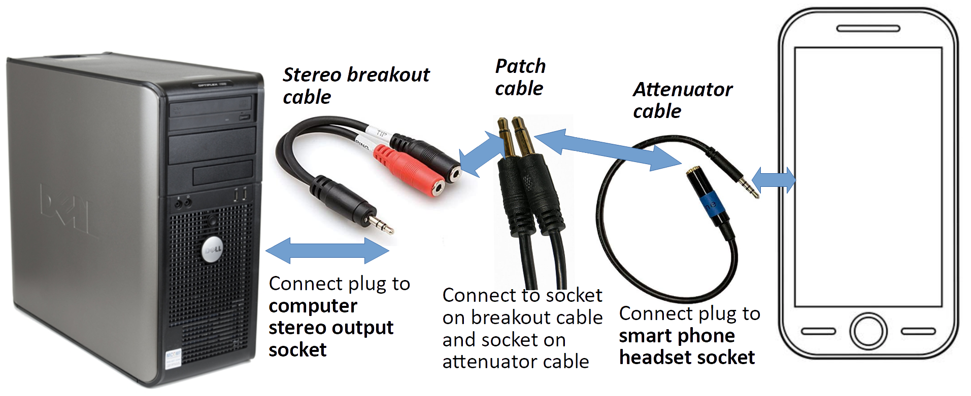Illustration 4
For my initial attempt, during which I found the volume was too low, I used an inexpensive set of cables, as shown in Illustration 4. Overall, this cable set costs only about $35 on Amazon. The most expensive is the Attenuator cable, at about $22. Please note that the patch cable is monophonic since the microphone input on the phone headset socket is monophonic.

Recently, my son found audio software for his Windows 10 laptop that drives the speaker output to greater audio volume than is possible using the normal Windows 10 audio controls. The software, I thought, could eliminate the sound amplification hardware requirement. That would make the original, least expensive cable set shown in Illustration 4 work.

I found the software my son uses, Sound Booster by Letasoft, which works for 14 days as a free trial, though the free trial version drops out the volume boost for 5 seconds once every 2 minutes. Also, Sound Booster is available for Windows only. So, I found some alternatives to Sound Booster. I cannot test all the other options, and I do not have a Mac for testing in any event. Here is a table listing many of the alternatives.

Software title | Download from | Works on Mac | Works on Win10 | license
Boom 2 | https://www.globaldelight.com/ | yes | yes | Single payment $14.99
Sound Booster Lite | https://soundbooster.froyosoft.com/soundbooster.php | yes | no | Free
DeskFX | https://www.nchsoftware.com/deskfx/index.html | yes | yes | Free for personal use
Table 1. Software for increasing computer audio volume

Once you establish a setup like this, I suggest you do some tests with the Voice Memos app of the iPhone to find an appropriate volume knob setting on the stereo receiver. You can find that app in the iPhone Utilities folder. Fortunately, there is no need to block the physical microphone on the iPhone since connecting audio into the microphone connection in the headset socket disables the iPhone physical microphone.

Before you record your combined greeting as a custom voicemail greeting, I suggest you practice the steps required to start that greeting recording process a few times so the steps become familiar.

THE BOTTOM LINE

If you feel plagued with robocalls and their voicemails, as I did, the results will justify the work and the dollars. As I mentioned in Part 2, while using such a combined greeting on my smartphone, my rate of incoming robocalls has fallen from 25 per week to 2 per week, and my rate of robocall voicemails has fallen from 10 per week to zero per week, in about eight months.

ABOUT THE AUTHOR: John Krout has been writing about creative uses of personal computers since the early 1980s, and more recently, about creative uses of smartphones. He finished a long career as a software engineer with 14 years as a technical writer for a federal contractor. He lives in Arlington, Virginia, with his son, many computers and cameras, and too many cats.

